

MATHEMATICS
METHODS

Test 2 – Equations, Polynomials, Functions and Graphs

Chapters 1 and 4
Semester 1 2016

Section Two - Calculator Assumed

Time allowed for this section
Working time for this section: 40 minutes
Marks available: 40 marks

Material required/recommended for this section

To be provided by the supervisor
This Question/Answer booklet
Formula sheet

To be provided by the candidate
Standard items: pens, pencils, pencil sharpener, eraser, correction fluid, ruler, highlighters

Special items: drawing instruments, templates, notes on one unfolded sheet of A4 paper, and up to three calculators satisfying the conditions set by the Curriculum Council for this course.

Important note to candidates
No other items may be used in this section of the examination. It is your responsibility to ensure that you do not have any unauthorised notes or other items of a non-personal nature in the examination room. If you have any unauthorised material with you, hand it to the supervisor before reading any further.

Multiple choice questions – select the best response
- Find the domain and range of .
A Domain {x: all real x}, range {y: all real y}
B Domain {x: all real x ≥ 2}, range {y: all real y ≥ 0}
C Domain {x: all real x ≠ 2}, range {y: all real y ≥ 0}
D Domain {x: all real x ≤ 2}, range {y: all real y ≥ 0}
E Domain {x: all real x ≥ 2}, range {y: all real y ≤ 0}

- Determine the solutions of p(x) = 2x3 + 9x2 − 5x
A − 5, 0, B , 0, 5
C 0, 1, 5 D 0, 2, 5
E −5, 0, 2

- Factorise x3 + 6x2 + 5x – 12.
A (x – 1)(x – 3)(x + 4) B (x – 1)(x + 3)(x + 4)
C (x – 1)(x – 3)(x – 4) D (x + 1)(x – 3)(x + 4)
E (x + 1)(x + 3)(x – 4)

- Solve the equation 2x² + 7x − 3 = 0, for x correct to 2 decimal places.
A x = −3.89 and 0.39 B x = −0.5 and −3
C x = −0.77 and −7.72 D x = 0.39 and 3.89
E x = 0.77 and 7.72

- Solve the equations 8a + b = −12 and 4a − 3b = −20 simultaneously.
A a = 2, b = −28 B a = −3.5, b = 16
C D a = 2, b = −28
E a = −2, b = 4

Short Answer Questions
- (2 marks)
Solve 3x2 – 5x – 12 = 0

- (2 marks)
For the function P(x) = 2x3 + 4x2 – x + 1, find the remainder when P(x) ÷ (x – 4)

- (4 marks)
State domain and range of the following functions:

- (3 marks)
The amount of fuel used by a car is directly proportional to the distance travelled. On a trip of 810 km, a family car used 60 litres of fuel. How far could the car travel on 76 litres of fuel?

- (6 marks)
For the given points A(−2, 3) and B(−1, −4):
- find the midpoint M of A and B

- find the distance between A and B

- find the gradient of line AB

- (4 marks)
Graph
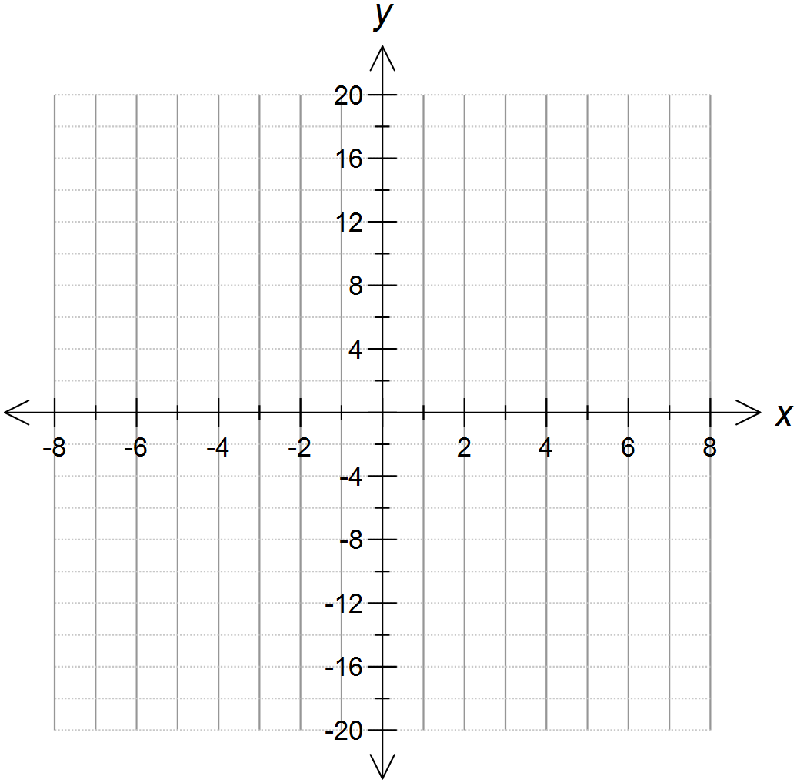
- (14 marks)
A Wilderness Trekking tour operator offers complete packages to the Tasmanian World Heritage areas from Launceston. The cycling tours may be from 3 to 12 days in length. They cost $780 for the 3-day tour and $180 for each additional day.
- Draw a graph showing the cost of the cycling tours. [4]

b. Find a relationship between the number of days and the cost of the tours. [2]

The operator also offers walking treks of any duration from 1 to 20 days with a flat rate of $210 per day.
c. Draw a graph of the cost of the walking treks. [4]


d. Find a relationship between the number of days and the cost of the treks. [2]

e. State the circumstances under which each of the walking or cycling options would be cheaper. [2]

End of Test

